Assignment 2 – distributed systems

Vaida Diana-Laura, group 3

Conceptual architecture of the distributed system

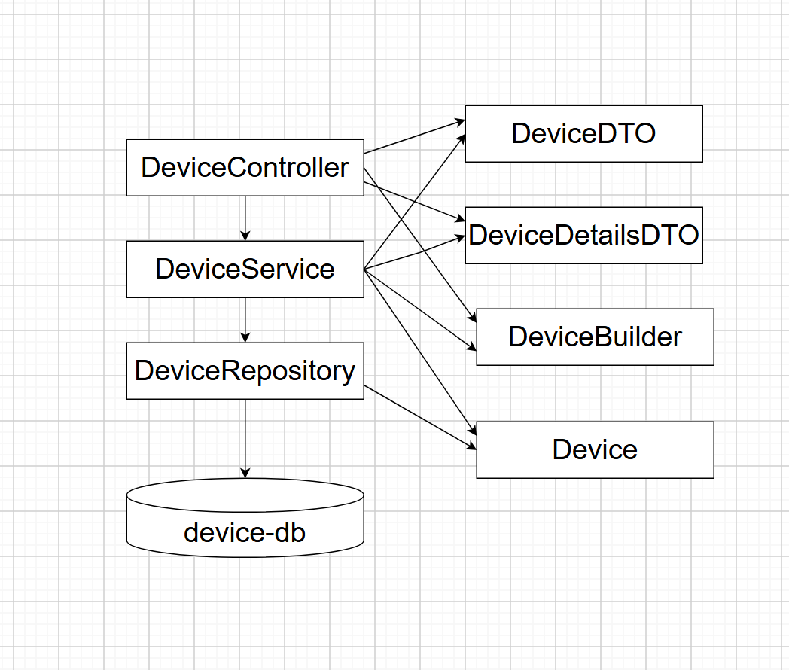

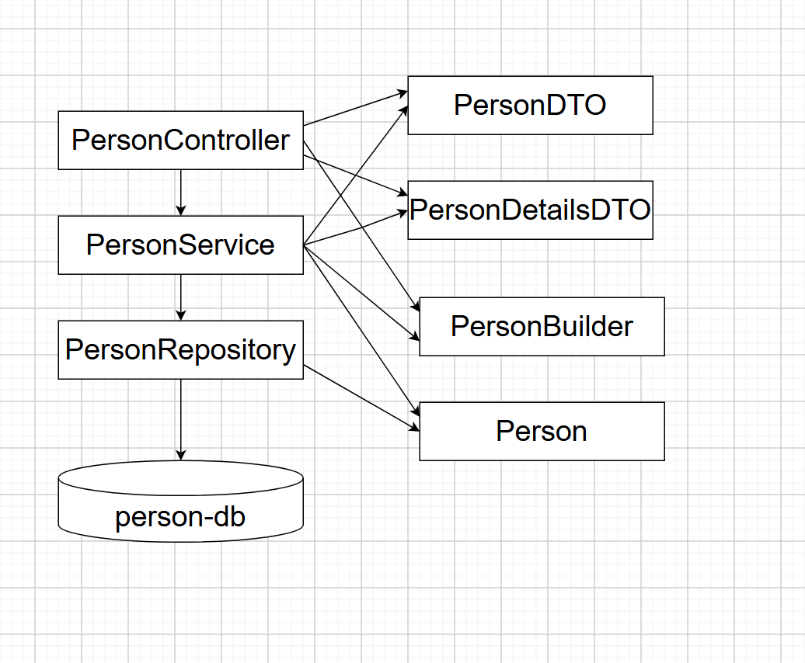

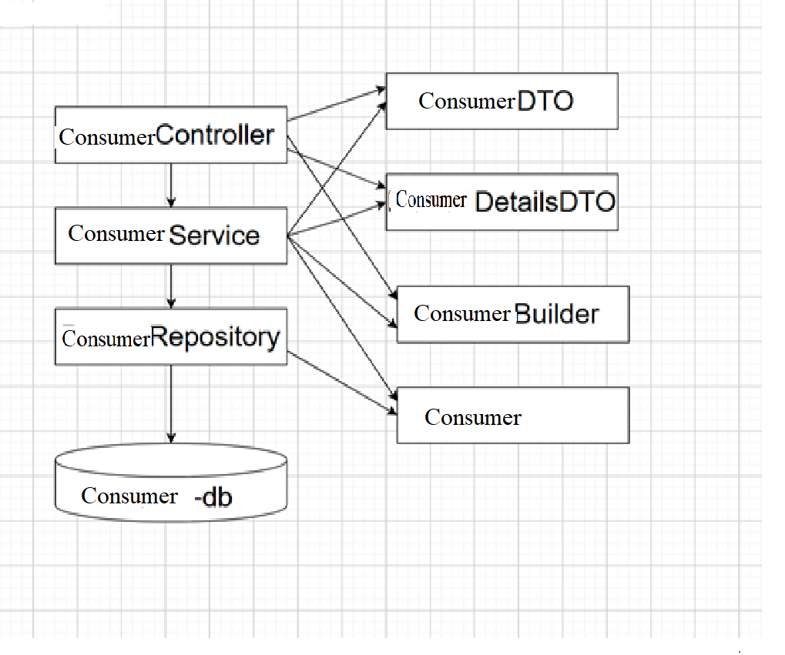

UML Deployment diagram

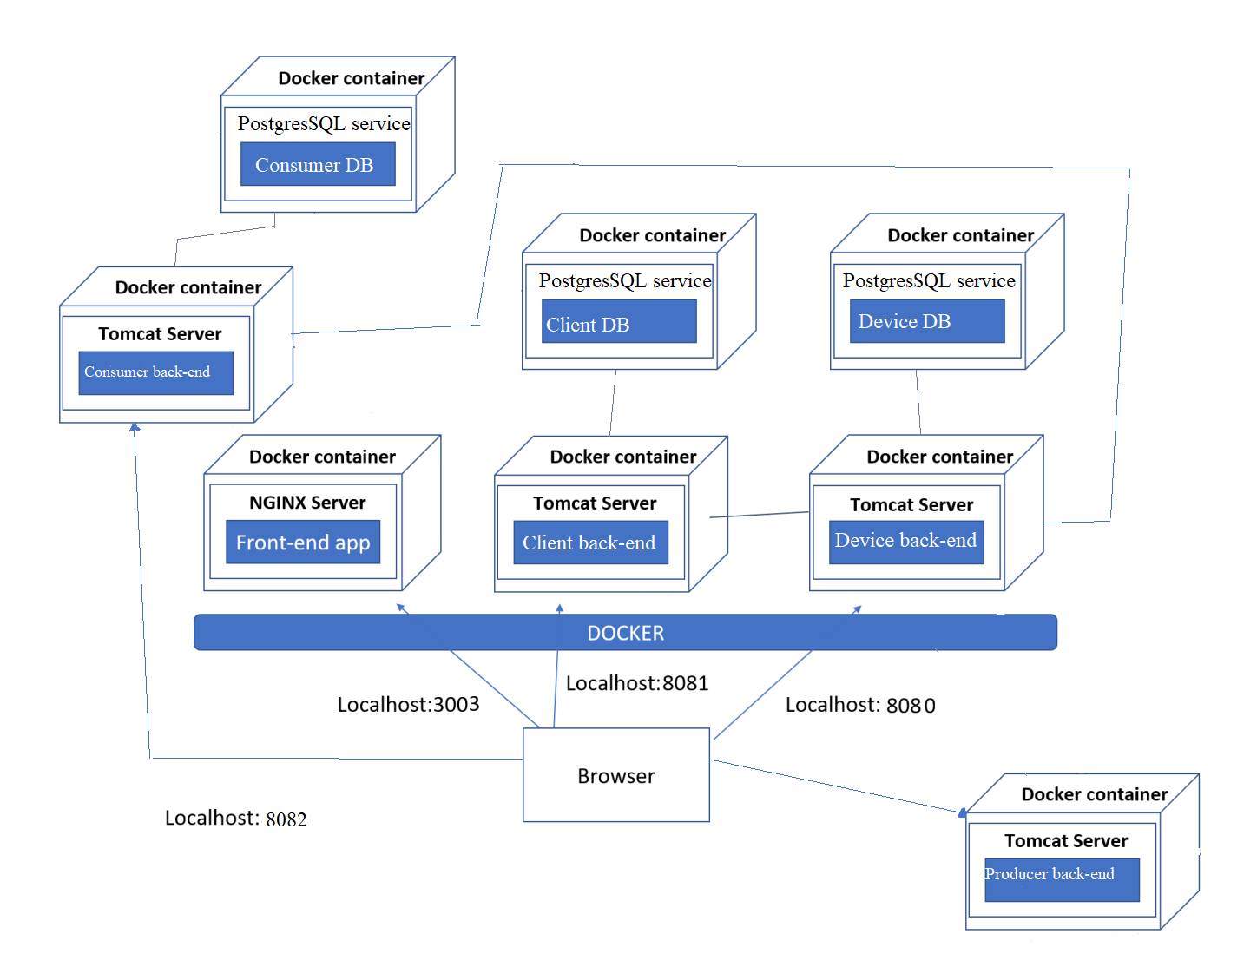

My project works for the back end with Spring Boot(in Intellij Idea) and front end with React (in Visual Studio Code). My microservices are Person and Device with their respective databases. I also have a producer and consumer microservice. The consumer microservice also has a consumer database.

My Monitoring and Communication Microservice(consumer microservice) communicates with the Monitoring database(consumer database) in my case.

The producer microservice has a config file where the id for a specific device is stored, it also has a sensor csv, where the values for energy consumption are. It has 2 queues with RabbitMQ, the first queue send the id of the device, searches it in the database and sends it with the maximum hourly consumption rate. The second queue uses the sensor file and sends the value along with the timestamp(the time in unix) and the id of the device. I manipulated the time, so a second is 10 minutes(so the simulator will work as intended and wouldn’t take as much time as needed, and 6 values would form an hour.

The information sent to the consumer microservice comes from those 2 queues from RabbitMQ. My consumer database has 2 tables – an Events table – where updates about the device are kept, with states like INITIALIZED and UPDATED, with a value for the consumption every hour. At first the value for the energy consumption is the initial value from the device database. When UPDATED, the new value is the consumption from every hour. It also has an Hourly Energy Consumption table – where information about the device are kept, the id, timestamp, consumption value.